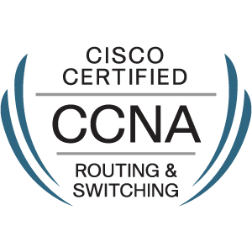RESUME

**BODDU DEEKSHITH**

8099247347

[deekshith.b.yadav@live.com](mailto:deekshith.b.yadav@live.com)______________________________________________________________

**CAREER OBJECTIVE**

Seeking a challenge technical position in working environment for me to continue practicing and expanding my skill set and knowledge base to attain success of the company and to the growth of fast developing field.

**STRENGTHS**

* Adaptive to changing environment.
* Leadership qualities.
* Creative.
* Able to work under pressure.
* Excellent oral and verbal ability.
* Confident.
* Eye for detail.

**TECHNICAL SKILL SET**

* Expertise in CISCO networking components.
* Knowledge of various vendors like CISCO, JUNIPER, HUAWEI.
* Working with protocols like RIP, IGRP, EIGRP, FTP, OSPF, BGP.
* CISCO auto/manual switches.

**RESPONSIBILITIES**

* Co-ordinate, configure and install network configuration, softwares etc., configure routers, switches and make sure that cables are connected properly is one of the duty of Cisco network engineer.
* VPN connectivity to various branches.
* LAN,WAN and wireless connectivity.
* Monitoring network is the another duty and give prompt support when any issue pop-ups
* Promptly report to management about the network performance reports, current status of the network time.
* Troubleshooting and resolving all the network related issues.

**CERTIFICATION**

Cisco Certified Network Associate (Routing & Switching) **CSCO12775843**.

**SOFTWARE SKILLS**

Languages : C, C++, Java

Databases : oracle10g

Operating system : Windows family, Linux.

Applications : MS-Office, Auto Cad, Adobe Photoshop.

**ACADEMIC QUALIFICATION**

* B.Tech Computer Science & Engineering(69.2%) from Kshatriya college of engineering, JNTUH in 2013.
* +2 from Narendra junior college(64.2%).
* SSC from Sri vani high school(75%).

**PERSONAL PROFILE**

Name : BODDU DEEKSHITH

Father’s name : BODDU SUDHAKAR

Gender : male

Date of Birth : 14-09-1990

Religion : Hindu

Nationality : Indian

Linguistic Ability : English, Hindi, Telugu

Permanent address : 4-70/5/17A, Yogeshwara colony, Armoor, Nizamabad,

Telangana-503224.

**DECLARATION:**

I hereby declare that all the details furnished above are true to the best of my

knowledge and belief.

Place: Hyderabad BODDU DEEKSHITH